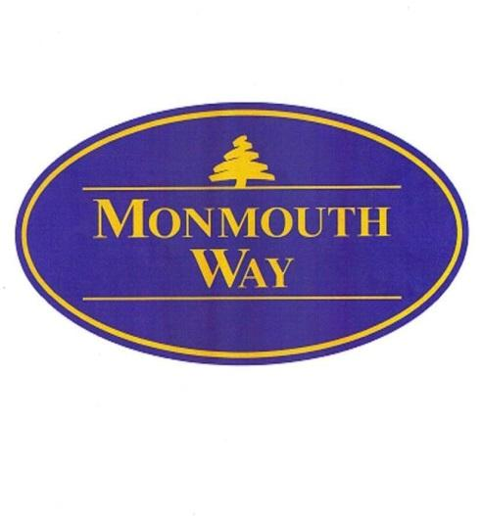 | A Community Newsletter for Owners and Residents  September-October 2026  Quick links:  - Edgewater Management Group: https://www.edgewatermg.com  - Monmouth Way Condominiums: https://monmouthway.org  Managing agent, Kelly Lambert:  cell and text: 518-281-0043; office: 518-577-5403  Edgewater Management Group, Inc., P.O. Box 150, Fort Edward, NY 12828

Board Membership. Regretting not running for a vacant Board seat? It’s not too late to join. Any owner interested in becoming a member of the Board should reach out to Managing Agent Kelly Lambert.

Flagpoles. An External Request Change form must be submitted for numerous requests, including the installation of a flagpole. Flagpoles are only allowed on decks. They are no longer approved for areas near front doors. External Request Change forms may be found on the MonmouthWay.org website.

Reminders.

- Electrical conduits from heat pumps to the building are the sole responsibility of the unit owners.
- Chimney/flue cleaning/maintenance certification are due annually.
- Landlords need to keep tenants informed of all HOA rules.

See something/say something. Lamp posts and lights above entry doors are repaired as needed. If you see something that needs to be fixed, please report it to Kelly Lambert.

Utility Room Access. Access to the utility room for contractors (i.e., Verizon, Spectrum, contractors) needs to be requested from our managing agent at least 24 hours in advance.

Good Housekeeping.

- All trash needs to be bagged and placed inside the dumpster. Dumpster doors (top and side) should be always closed.
- Do not overflow the dumpster. If the dumpster closest to your unit is full, one of the other 6 will probably have room for you.
- If the doors do not shut on the dumpster, County Waste charges extra. Extra charges equal increased budgets, which equals higher HOA rates.
- Contact County Waste at (518) 877-7007 to make arrangement for proper disposal of bulky items (beds, sofas, etc.). You are responsible for this additional charge. Management should be notified that arrangements made.

Comments, suggestions, and questions. Direct all comments, suggestions, and questions to our managing agent, Kelly Lambert, not to current Board members. Tenants should direct any comments, questions, suggestions to their property owner.

DUMPSTERS

Improper use of dumpsters may contribute to increased monthly maintenance fees due to the contractor’s additional charge when the dumpsters are overflowing or the tops do not close.

One example of improper use is evident in this photo. More than half the dumpster is full of cardboard boxes that were not broken down. Instead of walking to one of the other dumpsters, residents left their trash on the ground. Trash left outside the dumpster will not be removed by the contractor.

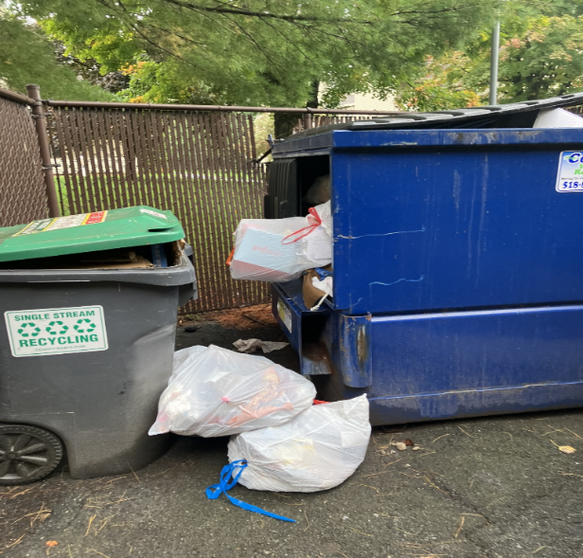

It is your responsibility to make sure your trash is correctly placed in the dumpster. If the dumpster closest to your unit is full, walk to another dumpster. There are seven (7) dumpsters on Monmouth Way.

Dumpster rules:

- Cardboard boxes should be broken down and placed in the recycling bins. If the bins are full, place the flattened cardboard in the dumpster.
- All trash needs to be bagged and placed inside the dumpster. Dumpster doors (top and side) should be always closed.
- Do not overflow the dumpster. If the dumpster closest to your unit is full, one of the other 6 will probably have room.
- If the doors do not shut on the dumpster, County Waste charges extra. Extra charges equal increased budgets, which equals higher HOA rates.
- Contact County Waste at (518) 877-7007 to make arrangement for proper disposal of bulky items (beds, sofas, etc.). You are responsible for this additional charge. Management should be notified that arrangements made.

